Task 2: Header Test cases

ID: 1
Title: Logo redirection to Main page
Preconditions: User is on any page except the Main page
Steps to reproduce:
- Click the logo in the header
Expected result: User is redirected to Main page
Status: Passed

ID: 2
Title: Support button functionality
Preconditions: User is on the Main page
Steps to reproduce:
- Click the Support button in the header
Expected result: The new window with project support opportunities is opened
Status: Passed

ID: 3
Title: Copy link functionality
Preconditions: User is on the Main page
Steps to reproduce:
- Click the Chain button(Share this page)
- Click Copy link
Test data:
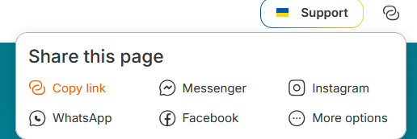
Expected result: The page URL is copied to the clipboard, button text is changed to “Copied!”
Status: Passed

ID: 4
Title: Share via Messenger
Preconditions: User is on the Main page
Steps to reproduce:
- Click the Chain button(Share this page)
- Click Messenger
Test data:
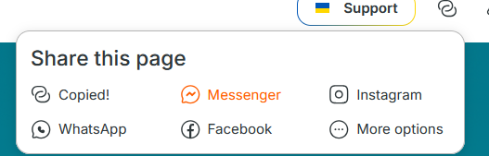

Expected result: Messenger share dialog opens
Status: Passed

ID: 5
Title: Share via Instagram
Preconditions: User is on the Main page
Steps to reproduce:
- Click the Chain button(Share this page)
- Click Instagram
Test data:
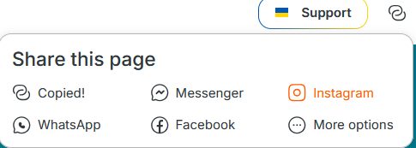
Expected result: Instagram share dialog opens
Status: Passed

ID: 6
Title: Share via WhatsApp
Preconditions: User is on the Main page
Steps to reproduce:
- Click the Chain button(Share this page)
- Click WhatsApp
Test data:
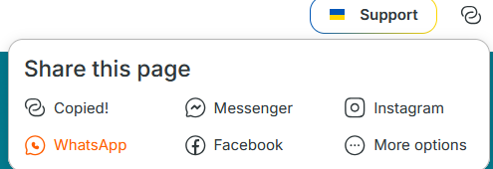
Expected result: WhatsApp share dialog opens
Status: Passed

ID: 7
Title: Share via Facebook
Preconditions: User is on the Main page
Steps to reproduce:
- Click the Chain button(Share this page)
- Click Facebook
Test data:
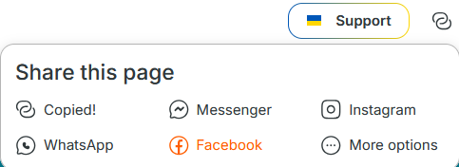
Expected result: Facebook share dialog opens
Status: Passed

ID: 8
Title: Liked rooms button(first interaction)
Preconditions: User is on the Main page
Steps to reproduce:
- Hover the cursor over the Thumbs up icon
Test data:
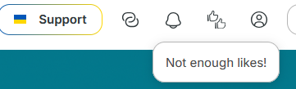
Expected result: Message “Not enough likes!” is displayed
Status: Passed

ID: 9
Title: Liked rooms button(active)
Preconditions: User liked at least one room
Steps to reproduce:
- Click Thumbs up icon
Test data:
Expected result: Comparison page is opened
Status: Passed

ID: 10
Title: Account drop-down
Preconditions: User is in the main page
Steps to reproduce:
- Click the User icon
Test data:
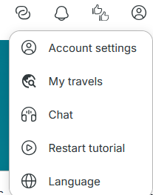
Expected result: Drop-down interactive list is displayed
Status: Passed

ID: 11
Title: My travels
Preconditions: Logged in user has opened drop-down account menu
Steps to reproduce:
- Click My travels
Test data:
Expected result: My travels dialog window is displayed
Status: Passed

ID: 12
Title: Chat centre in header
Preconditions: User has opened drop-down account menu
Steps to reproduce:
- Click Chat
Test data:
Expected result: Chat centre dialog window is displayed
Status: Passed

ID: 13
Title: Restart tutorial
Preconditions: User has opened drop-down account menu
Steps to reproduce:
- Click Restart tutorial
Test data:
Expected result: “Welcome to WinWin.travel!” tutorial window id displayed
Status: Passed

ID: 14
Title: Log out
Preconditions: Logged in user has opened drop-down account menu
Steps to reproduce:
- Click Log out
Test data:
Expected result: User is logged out and redirected to a new session
Status: Passed

ID: 15
Title: Register
Preconditions: User is on the Main page
Steps to reproduce:
- Click Register button in header
Test data:
Expected result: Registration window is displayed
Status: Passed

ID: 16
Title: Sign in
Preconditions: User is on the Main page
Steps to reproduce:
- Click Sign in button in header
Test data:
Expected result: Signing in window is displayed
Status: Passed

